**Arduino Tech Forum**

5+ тоест 80 точки

**Technology**

C# + ASP.NET MVC + Entity Framework + SQL Server + HTML + CSS

**Requirements**

Your project should implement **at least** the following **functionality**:

* User **registration** (and optionally user profiles) / **login** / **logout**.
* **View** all questions (optionally by category, optionally with paging), without a login.
* Ask a **new question** by the forum users (after login). Optionally question may have **tags** and **category**.

Larger teams should develop **larger projects**. The minimum number of application pages and database tables required for the project depend on the **count of team members**.

* Minimum (3 + **team_members_count**) **pages** (views).
* Minimum **team_members_count** **database tables** (or data collections / entities).
* Implement user registration, login, view content, create content.
* Implement **more functionality** by choice. Larger teams should implement more functionality.

**Optional Functionality**

* Add a WYSIWYG HTML Editor
* Implement **tags** for the forum questions.
* Implement **categories** for the forum questions.
* Implement adding **answers** to the questions by the forum visitors – each visitor must fill out his name, email (optionally) and comment text.
* **Counter** for visits for each question.
* Functionality for **searching** by question, answer and tags.
* Implement **ranking** according to user activity.
* **Admin panel**: add /edit / delete forum posts, tags, answers, categories.
* Post **new comment**. Anonymous users can specify their name. Logged-in users use their profile name.
* Implement **add / edit / delete category** in the admin panel
* Admin Panel with Icons
* Edit Posts, Edit Comments, Edit Categories, Edit Tags, Edit Users, Edit Files
* Add Roles "User" and "Administrator"

Implement tags

**Optional Functionality + Some More Ideas**

* Add a WYSIWYG HTML Editor – 1 ден
* Implement **tags** for the forum questions. – 1 ден
  + Въпроси
    - Отговори
  + На Теми
  + На юзъри
  + Таговете ще са свободен текст, бокс под поста
* Implement **categories** for the forum questions. – 1 ден
  + Админите
  + Implement add / edit / delete category in the admin panel
* Implement adding **answers** to the questions by the forum visitors – each visitor must fill out his name, email (optionally) and comment text. – 2 до 3 дни
  + Post new comment. Anonymous users can specify their name. Logged-in users use their profile name.
  + Comments със цитати will be displayed in quotes with the authors name and time – 1 ден
* **Counter** for visits for each question. – 1 ден
* Implement **ranking** according to user activity. – 3 дни
  + Every answer has its points given by the users and the user with the most points has the highest rank.
* Functionality for **searching** by question, answer and tags. – 1 ден
* **Admin panel** – 7 дни
  + Admin Panel with Icons
  + Edit Posts, Edit Comments, Edit Categories, Edit Tags, Edit Users, Edit Pictures
* Add Roles – 2 ден
  + User
    - Comment
    - Upload Pictures
    - Redact answer and question
  + Administrator
    - All access
  + Moderator
    - Redact Posts
    - Delete Posts
    - Delete Answers
* Deleted posts will delete all related links – 1 ден
* Notifications to answers – 1 ден
* Reactions to a registered user will be displayed first upon login and then under the normal posts – 1 ден
* Anchor to the top of the page
* On the Post there will be two buttons, one reply and one comment. The reply button will indent the text and the comment button will be posted directly underneath the original post, on the same level. When you reply for the second time the post will not be indented any longer. Only the first reply is indented. When someone upvotes a comment there will be a counter which indicates how many upvotes or - downvotes a comment has.

**Super Optional**

* Automatic Avatar Generation

**Team Members and Responsibilities**

|  |  |
| --- | --- |
| **Person** | **Tasks** |
| Angelina | Graphic Design |
| Luboslav | C# Back End & Front End |
| Antoan | Front End & C# Back End |
| Jay D | C# Back End |
| Angel | C# Back End |
| Denis | C# Back End |

**Home Page**

* New posts on the front page

User Name

Logo

Avatar

LogOut

**Topics by Category**

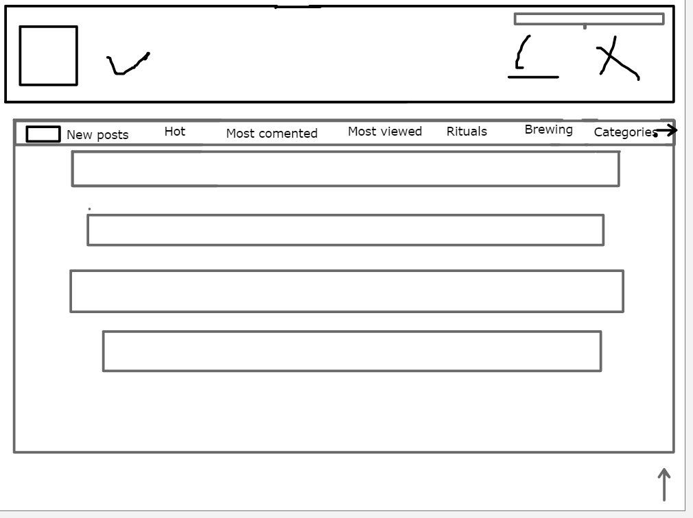

**User Home Page**

User Name

LogOut

Avatar

Logo

**Reactions to Posts and Questions**

**Topics By Category**

**General Topics**

**User Post**

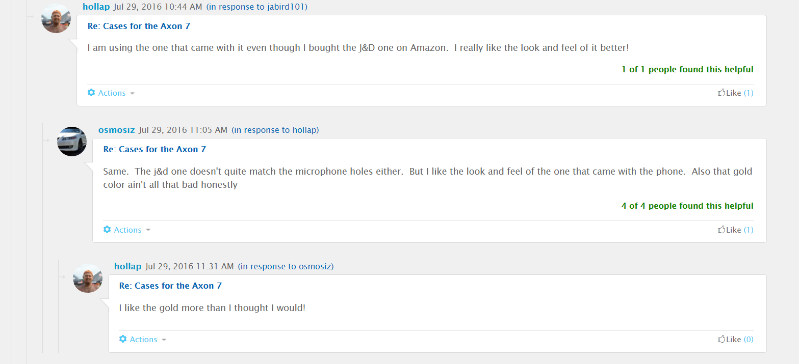

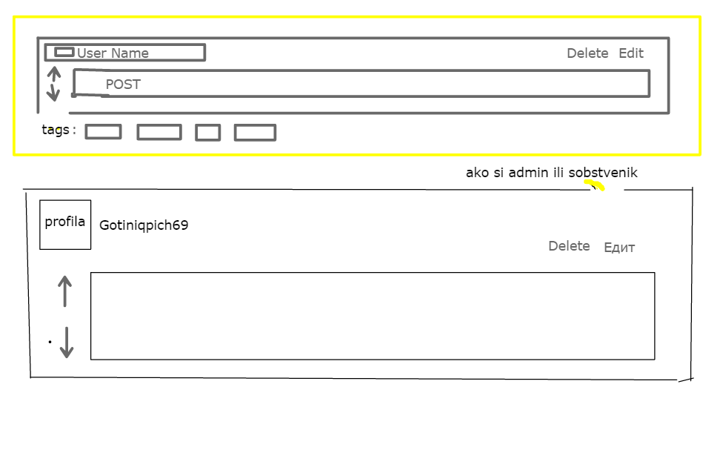

**Admin Panel**

